PlasmaGraph Poster Contents

# Logos



# Abstract (Reference)

PlasmaGraph is a Matlab data graphing program designed by Plasma Visualization Group members Daniel Quintini Greco and Gerardo Navas Morales for the Polytechnic University of Puerto Rico’s Plasma Laboratory. The program is designed with ease of use in mind, providing a graphical interface with which to select the data to graph and the graph’s settings, such as columns to graph, column labels, and the inclusion of additional tools such as data regression. When provided a specially-formatted Matlab data file and a number of settings, the program produces a graph composed of the data and its settings. PlasmaGraph will serve to facilitate the PUPR Plasma Laboratory students’ efforts to analyze the experiment data obtained from the Laboratory’s Mirror and Cusp Plasma Machine.

# Introduction

The Polytechnic University of Puerto Rico currently runs a Plasma Laboratory wherein students perform various experiments under the supervision of Professor Angel Gonzales-Lizardo. The laboratory currently utilizes Matlab [1], a mathematical calculation and analysis software, to graph the resulting data, but the students find Matlab’s complex programming language difficult to use for complex graphs. As a result, Professor Angel Gonzales-Lizardo has requested for a specialized graphing program to use instead of Matlab.

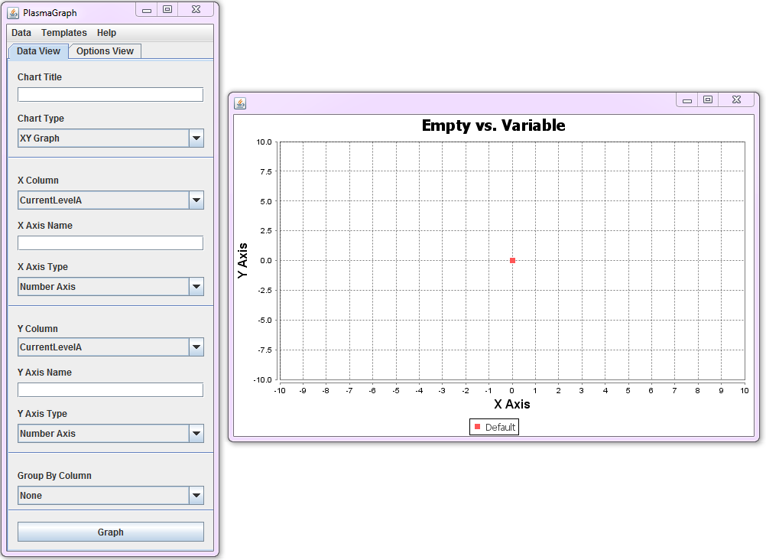Figure 1: Program Screenshot

# Objectives

* Create a graphing solution for the PUPR Plasma Laboratory.
  + Reads Matlab data files.
  + Provides a Graphical User Interface to select settings.
  + Produce and save graphs.
  + Create regression lines based on data.
  + Group data based on a tertiary column.
  + Provide rudimentary outlier searching.
* Provide tools with which to add functionality in the future.

# Data

The data the PUPR Plasma Laboratory collects is stored within Matlab Level-5 data files in the following manner:

* The file must be a Matlab-produced Level-5 binary file. [2]
* The file must contain one or more variables.
* Each variable must contain a vector of length n and width 1.
* All variables in a file must contain the same number of values.
* Variables may only be of types “double” or “cell”.
  + Double variables are used to store numerical values.
  + Cell variables are used to store text values in the form of Character arrays.
* The file must not be larger than 36,500 KB.

This data file is read via the Java-based “JMatIO” Matlab file-reading tool [3]. If the data provided is formatted in this manner, PlasmaGraph updates the user interface with the available columns in the data file.

# Graphical User Interface

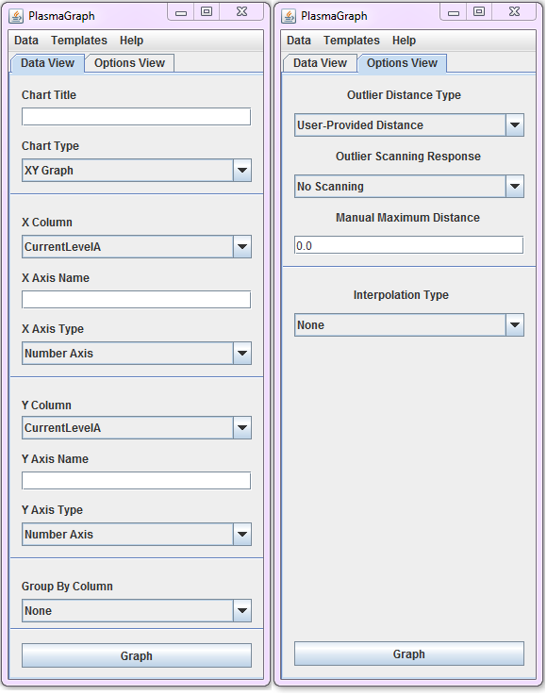Figure 2: Program GUI Settings

The Graphical User Interface (GUI), as shown above, provides the tools to manipulate graphs into the desired shape. The interface is separated into two sections:

* Data Settings: This window handles options related to the visual components of the graph’s data, such as columns to graph, column axis names, graph title, and grouping column.
* Tool Settings: This window handles options related to the optional tools available in PlasmaGraph, such as the Interpolation or Outlier Search capabilities.

Furthermore, the program allows the user to view the data contained in the file via the “View Data” option on the Menu Bar.

# Graphing

PlasmaGraph utilizes the tools provided by the Java-based “JFreeChart” library [4] in order to create graphs. The program obtains the translated data file and, alongside the options selected via the GUI, is able to provide a graph representative of what the user selected.

Figure 3: Example PlasmaGraph Graph

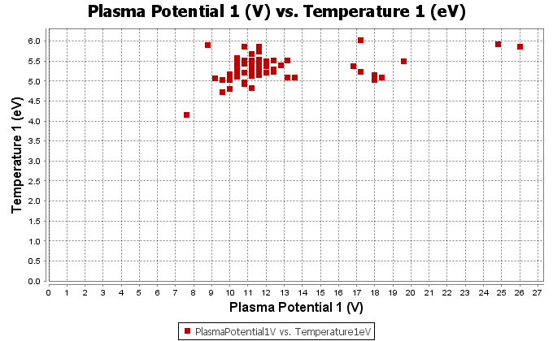

# Conclusion

PlasmaGraph is a user interface-driven graphing solution with a good number of available data analysis tools. Its open-source nature will allow parties interested in its development, whether they may be a part of the PUPR Plasma Laboratory or not, to help in its development. Through the work performed in this project, we are confident that PlasmaGraph will be a very important tool for the laboratory.

# References

|  |  |
| --- | --- |
| [1] | The MathWorks, Inc., "MATLAB - The Language of Technical Computing," [Online]. Available: http://www.mathworks.com/products/matlab/?s_tid=hp_fp_ml. [Accessed 12 May 2014]. |
| [2] | The Mathworks, Inc., "MATLAB® MAT-File Format," September 2013. [Online]. Available: http://www.mathworks.com/help/pdf_doc/matlab/matfile_format.pdf. [Accessed 26 January 2014]. |
| [3] | t. t. w. cbwatcham, "JMatIO - Matlab's MAT-file I/O in JAVA," 04 December 2012. [Online]. Available: http://sourceforge.net/projects/jmatio/. [Accessed 14 May 2014]. |
| [4] | Object Refinery Limited, "JFreeChart," Object Refinery Limited, 25 November 2013. [Online]. Available: http://www.jfree.org/jfreechart/. [Accessed 13 May 2014]. |